PD Reports

This article provides instructions and details on generating PD Reports.
- Mar 1, 2024
- Knowledge
Article Body
Contents: Activity By User | Summary for user by Tags | Summary by User | Summary by Tags | License Progress by User | License Audit Report | Budget Spending By User | Attendees List Report | Reimbursable Hours by Teacher and Code |
Vector Professional Development provides users with a set of reports that enable the user to make data-driven decisions and monitor progress and compliance in professional development. From teacher to evaluator to district office staff, reports and dashboards are customized to meet your individual needs. You can view, print, and export reports to meet your needs.
When you want to run a report you would first click on the Reports Icon on the left-hand side of the page when you are logged in 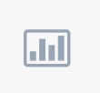
From here, click on the PD Tracking heading to see all the reports available to you.
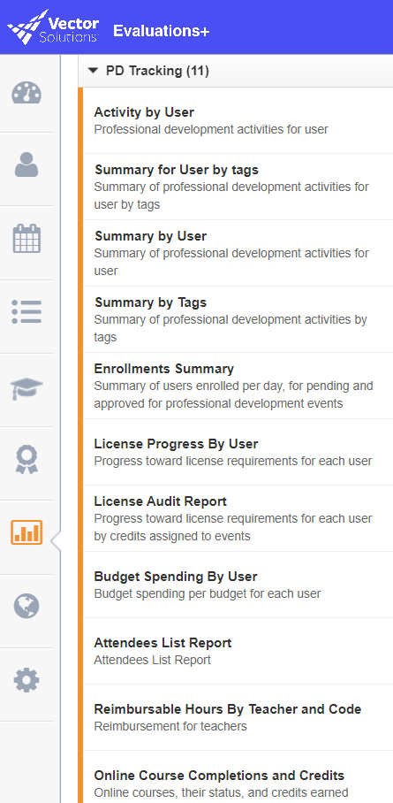
For all reports you can use the filters as well as the Advanced Filters if you need to run reports on specific groups:
You can also select a group
NOTE: You will only be able to run reports on data that you have permission to view, so educators without evaluator permission will only be able to run reports on their own data which limits which reports you can see. If you are an evaluator you will only be able to see data from yourself and your evaluees.
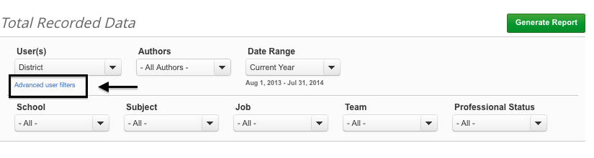

ACTIVITY BY USER
Who can run this report: Teachers, Evaluators, and Administrators
Description: A detailed list of all professional development activities for a user including the name of the program, date of the event, and credits awarded
Filters: Users, Date Range, User Properties, Program Name
Advanced Filters: School, Subject, Job, Team, Professional Status, Department, Regions
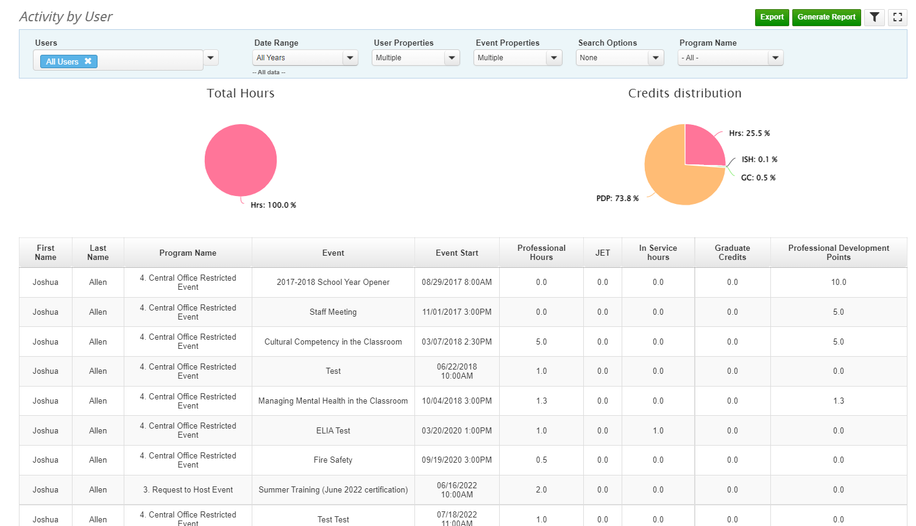
Back to top

SUMMARY FOR USER BY TAGS
Who can run this report: Teachers, Evaluators, and Administrators
Description: If you use tags as a way to capture program data, this report will give you a list of all professional development activities by tag
Filters: Users, Date Range, User Properties, Tags
Advanced Filters: School, Subject, Job, Team, Professional Status, Department, Regions
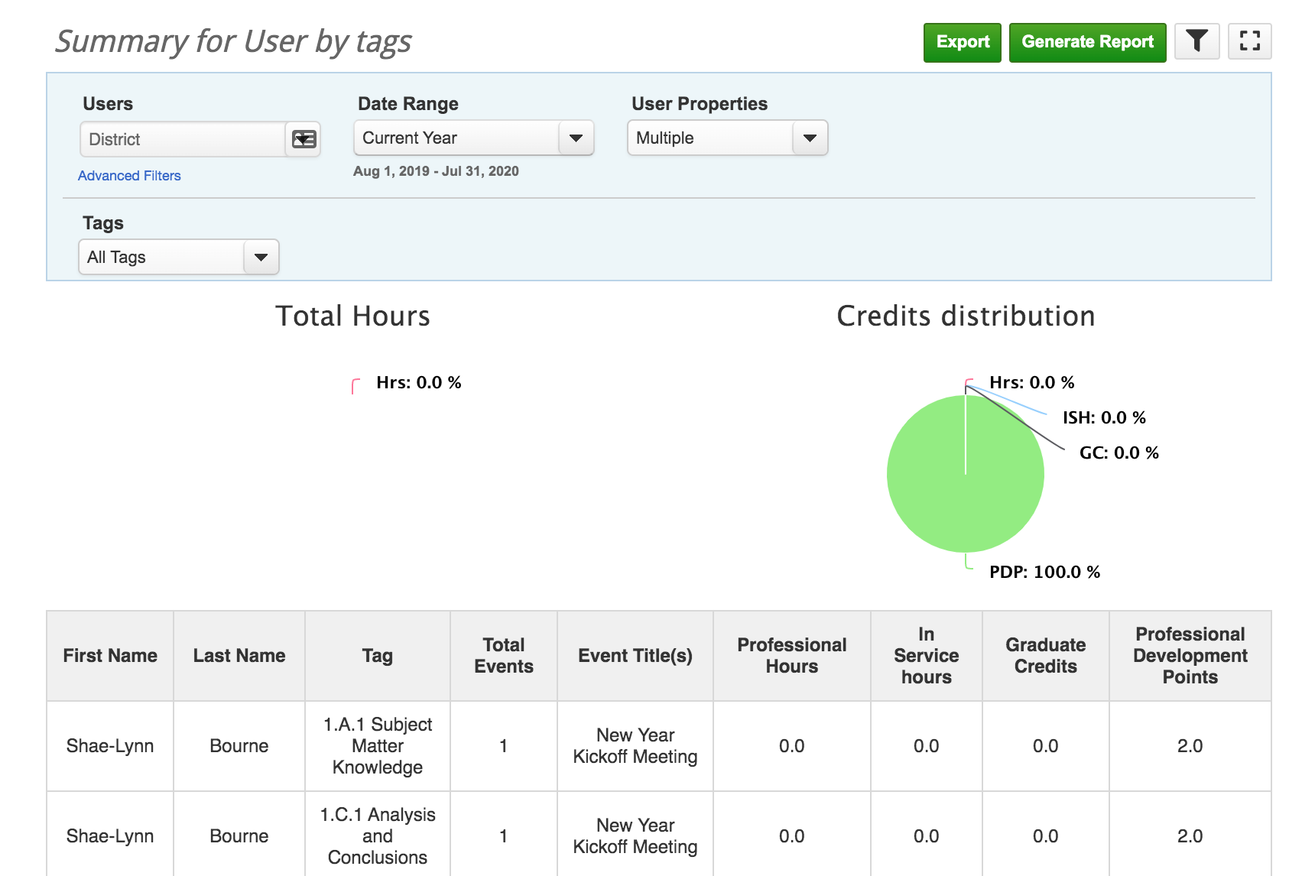
Back to top

SUMMARY BY USER
Who can run this report: Teachers, Evaluators, and Administrators
Description: Gives the total amount of events and credits for a user over a given period of time
Filters: Users, Date Range, User Properties
Advanced Filters: School, Subject, Job, Team, Professional Status, Department, Regions, Show Users Without Data
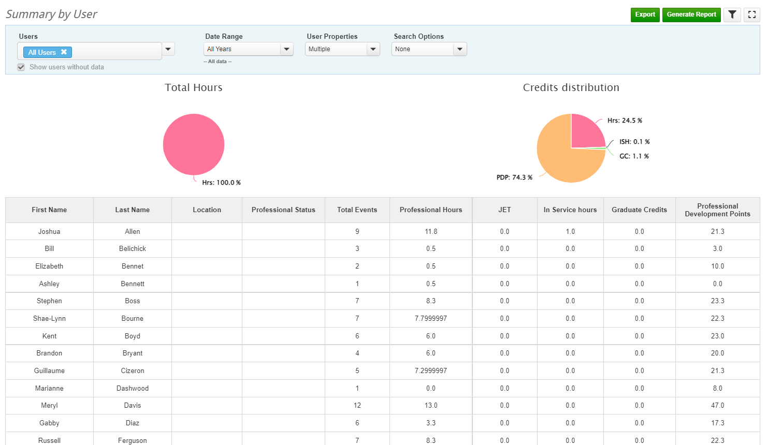
Back to top

SUMMARY BY TAGS
Who can run this report: Teachers, Evaluators, and Administrators
Description: Gives a summary of all PD events by tags
Filters: Users, Date Range, Tags
Advanced Filters: School, Subject, Job, Team, Professional Status, Department, Regions
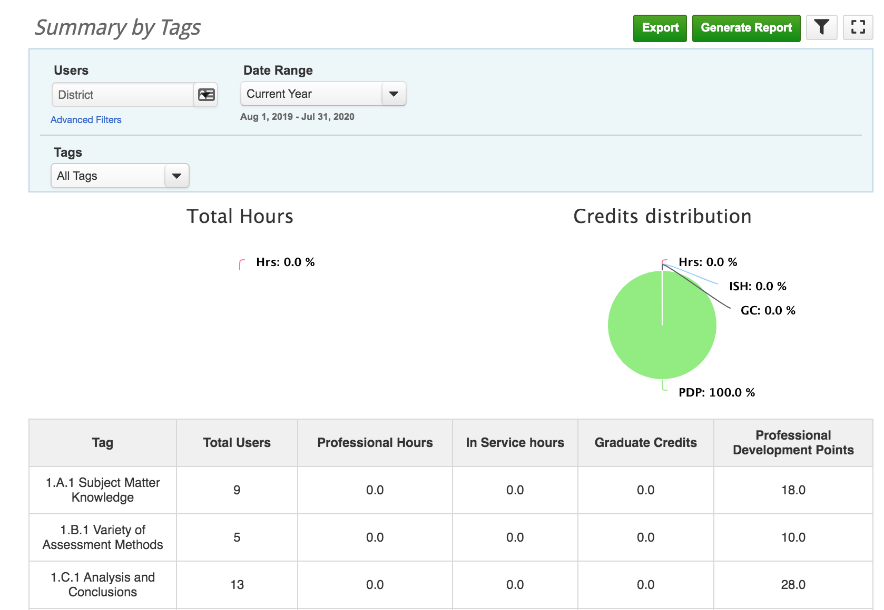

Back to top

LICENSE PROGRESS BY USER

Who can run this report: Evaluators and Administrators
Description: Gives a breakdown of users’ progress toward their license completion
Filters: Users, License, User Properties
Advanced Filters: None
* Note: This report will only show districts that have the License Tracking Tool active
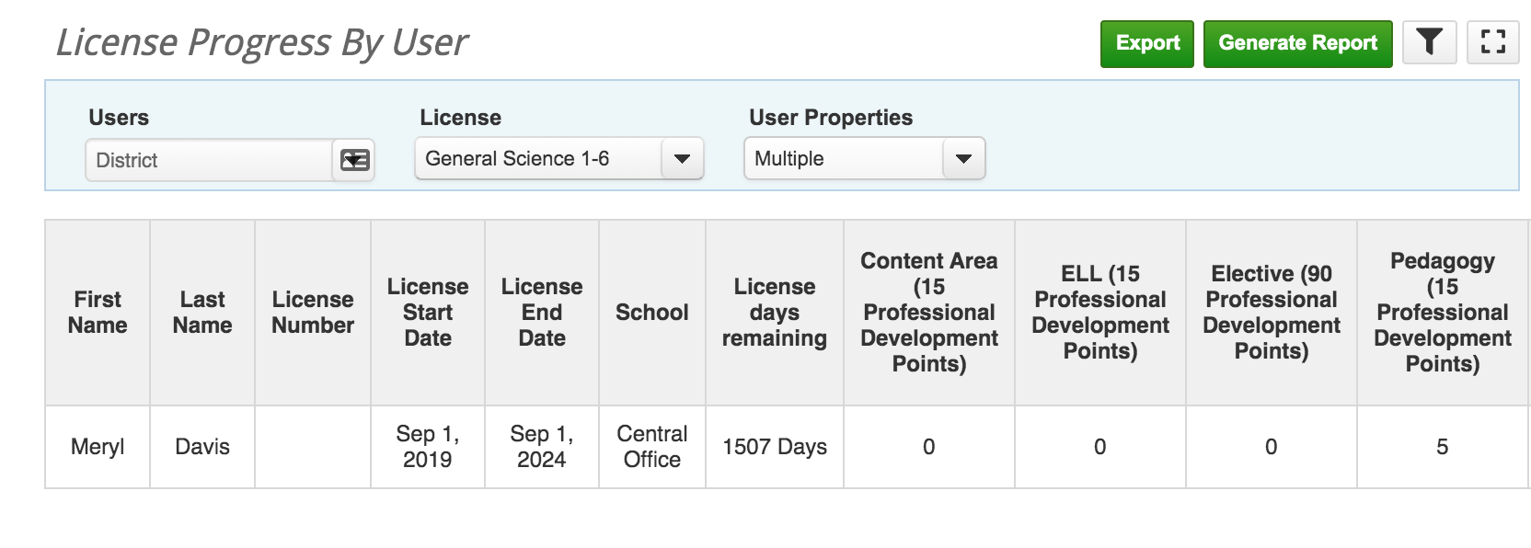
Back to top

LICENSE AUDIT REPORT

Who can run this report: Evaluators and Administrators
Description: Progress toward license requirements for each user by credits assigned to events
Filters: Users, License, User Properties
Advanced Filters: None
* Note: This report will only show districts that have the License Tracking Tool active
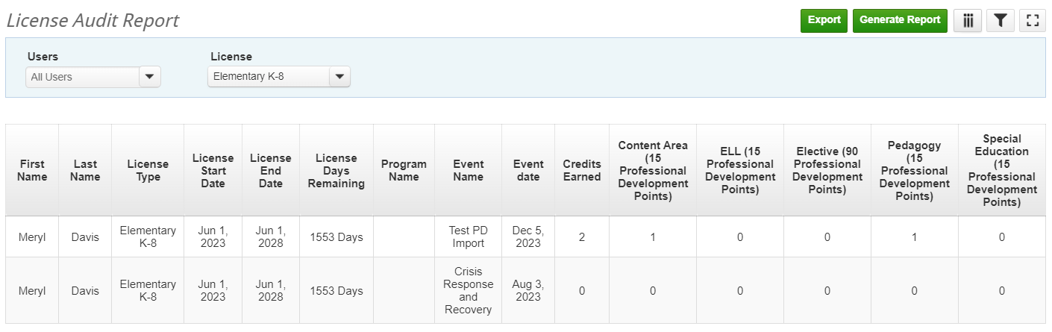

BUDGET SPENDING BY USER

Who can run this report: Evaluators and Administrators
Description: Provides an overview of a users’ budget spending by budget name
Filters: Users, Budget, User Properties
Advanced Filters: None
* Note: This report will only show districts that have the License Tracking Tool active
Back to top

REIMBURSEMENT HOURS BY TEACHER AND CODE
Who can run this report: Individual Users, District Administrators, anybody with “District Report Access”
Description: See a list of users who went to, and received credits for a reimbursable event. The event will generate the user name, name of the event, reimbursement code, subcode, and approved hours.
Filters: Users, Date Range, User Properties, and Level of Detail
Advanced Filters: School, Subject, Job, Team, Professional Status, Departments, Regions
Back to top

ATTENDEES LIST REPORT
Who can run this report: Evaluators and Administrators
Description: Gives an attendance report for one or many events in once place
Filters: Date Range, Authors, Events, Event Properties, User Properties, Search Options
Advanced Filters: None
* Note: “Search Options” will allow you to filter by Advanced Filter attributes and options. This filter will only appear if you have the feature activated in your district.
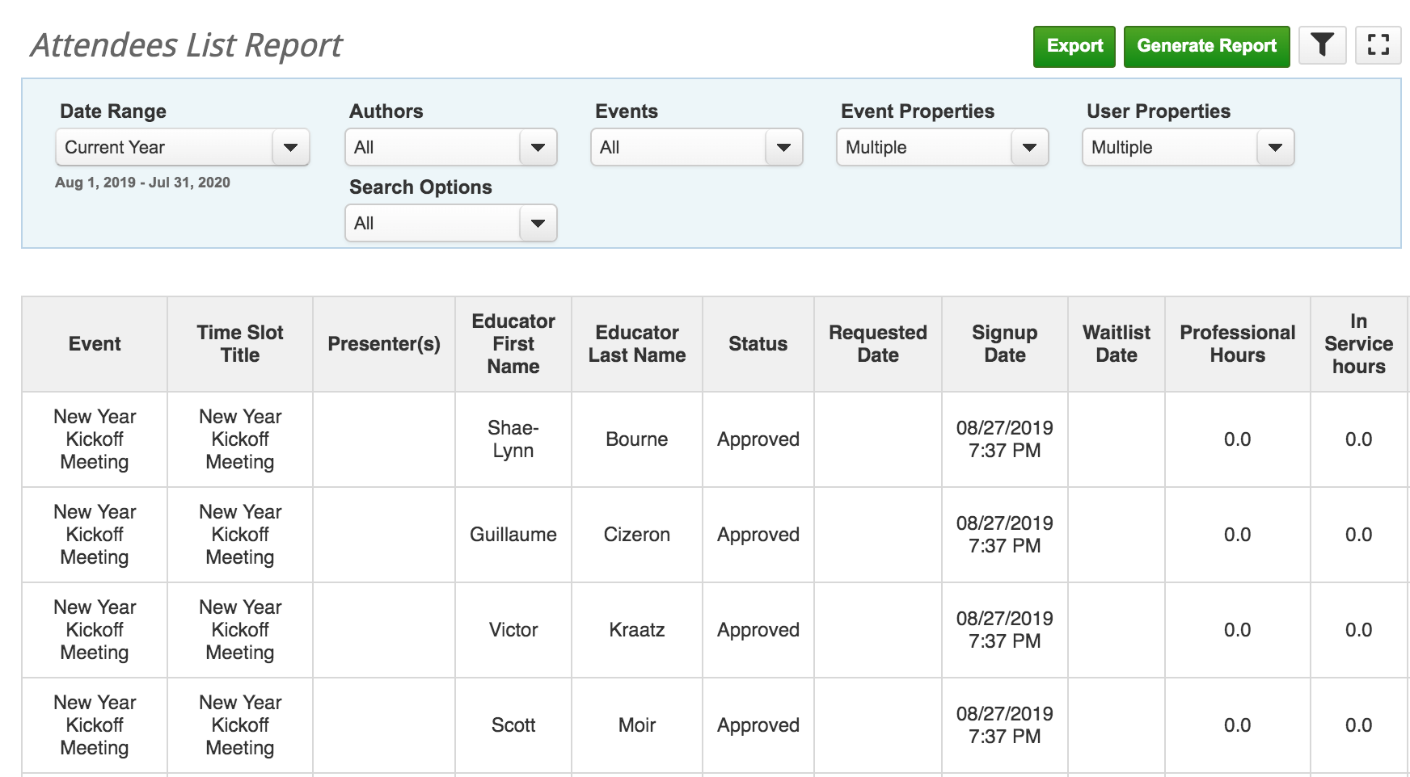
Back to top

ENROLLMENTS SUMMARY
Who can run this report: District Administrators, Evaluators, anybody with “District Report Access”
Description: Summary of users enrolled per day, for pending and approved professional development events. The event will generate the Date of the Event, Pending Enrollments, Approved Enrollment, Total Enrolled, Total Individual Events, Total Public Events, Total Restricted Events, and Total Events.
Filters: Users, Date Range, and Type of Event
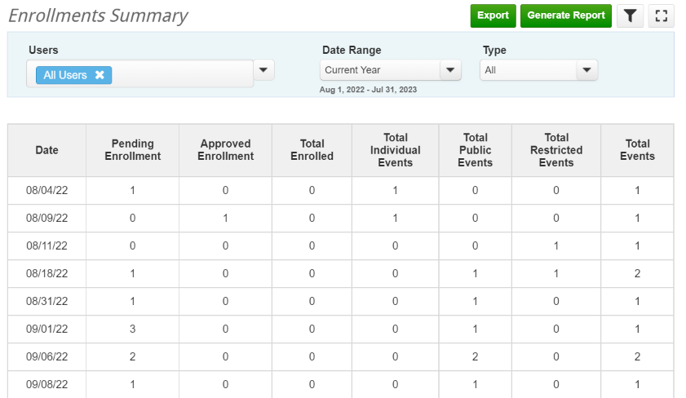

ONLINE COURSE COMPLETIONS AND CREDITS
Who can run this report: Evaluators and Administrators
Description: Online courses, their status, and credits earned
Filters: Date Range, Source, Course Title, Course Properties, and Course Status
Advanced Filters: None

